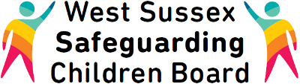
West Sussex Safeguarding Children Board
Call: 0330 222 7799
Email: lscb@westsussex.gov.uk

- Home
- Multi-Agency Safeguarding Hub (MASH)

From the 1st April the workforce of the Children’s Access Point and the Early Help Resource Centre were combined. The Multi-Agency Safeguarding Hub (MASH) will be single point of contact for all safeguarding concerns regarding children and young people in West Sussex which includes front door access for Early Help.
It brings together expert professionals, from services that have contact with children, young people and families, and makes the best possible use of their combined knowledge and resources to keep children safe from harm and promote these and their families wellbeing.
The MASH will do this by:
- Acting as a front door to manage all safeguarding concerns
- Researching information held on professional databases to inform decisions
- Continuing to provide support to professionals working in Early Help. Especially identifying families who need Think Family Keyworker Services and other key working services, and family network responses
- Providing a secure and confidential environment for professionals to share information
- Identifying low –level repeat referrals which taken in isolation may not appear concerning, but do when the child’s journey is reviewed
- Accessing quickly and efficiently the child protection investigation staff both within children’s social care, the Police and Health (holding strategy discussion centrally
Referring to the MASH
- Request for support E-Form: http://sussex.procedures.org.uk/
- Email: MASH@westsussex.gcsx.gov.uk
- Telephone: 01403 229 900
- Out of Hours: 0330 222 6664
- Emergency safeguarding concern : 07711 769657

