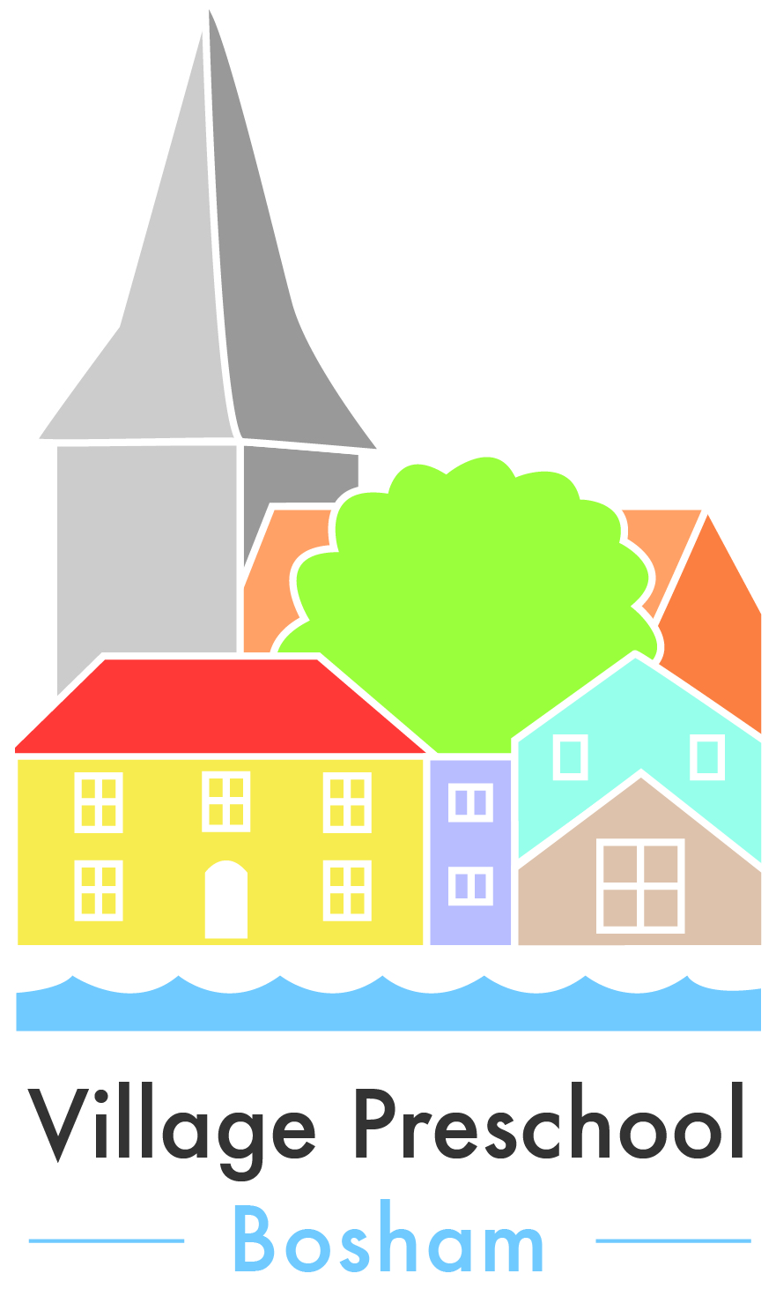

Fees and Funding Policy

This fees policy forms part of the contract with the parents/carer and Village Preschool Bosham. Village Preschool Bosham operates a service, which is fair and competitively priced. We aim to offer a high quality, safe and stimulating environment that provides a service that is good value for money. You are able to purchase sessions for children during term time on:

Monday, Wednesday, Friday 9am – 1pm Tuesday, Thursday 9am – 3.30pm

.

Booking, Fees and Billing

- The fee charged by the Preschool from 4th September 2017 is £11.50 per session. Fees will usually increase in line with the Early Years Entitlement rate. Notice of 4 weeks will be given of any fee increase.
- We require a non refundable registration fee of £25 to secure your child’s place at our setting, payable upon joining.
- All sessions reserved must be paid for. This includes if a child is absent due to short term sickness (1-7 days) or holiday. If a child has long term sickness, then charges will be reviewed on an individual basis.
- You will not be charged for the 8 standard Bank Holidays per year (New Year, Good Friday, Easter Monday, May day, Whitsun, Late August, Christmas day and Boxing day) or INSET days.
- If the Preschool is forced to close due to staff shortages alternative sessions will be offered to affected children. However if the Preschool is forced to close because of reasons outside of their direct control e.g. weather conditions, fees and funding would still be owed and claimed for these days.
- Invoices will be sent out at the beginning of each half term and fees are to be paid by the half term break.
- Fees may be paid in full or by instalments by individual negotiation.
- Fees should be paid by cheque or by Direct Transfer (please contact Nicki for this option, or refer to bank details on invoice).
- The fee charging periods are:

Autumn Term: 1st September – Half term – 31st December
Spring Term: 1st January – Half term - 31st March
Summer Term: 1st April – Half term -31st August

This is in line with the Government Early Years Entitlement periods.
- Your child will be allocated a start date based on their age and your request. If you decide to delay their start from this agreed date.
- 6 weeks notice of a cancellation of a place is required or full fees for 6 weeks will be charged.

It is expected that children will be collected promptly. Should there be unavoidable circumstances and you know you will be late to collect, you should do your best to contact the Preschool and inform them of the situation. Charges may be waived in these cases. Repeated late collections may result in the child’s place being reviewed.

Procedure for collection of late payment/non-payment of fees

- The Preschool will offer for fees to be paid by instalments.
- If fees remain unpaid upon the date payment is due, a phone call will be made requesting payment or for the parent to attend a debt recovery meeting within one week of the outstanding invoice. At the meeting a payment plan will be drawn up and signed by both parties.
- Should there be a default on the payment plan a letter will be sent requesting full payment within 7 days and the child will only be allowed access to Free Entltlement hours.
- Should fees still remain unpaid, we will proceed to reclaim the outstanding amount through the small claims court.

Village Preschool Bosham is sympathetic to financial difficulties and we will actively encourage a mutual agreement in order for fees to be paid. If you think you may have a problem paying fees by the date given, then you should contact the manager immediately so that the situation can be resolved.

Early Years Free Entitlement

We are in receipt of EYFE for 3 and 4 year olds as well as funding for eligible 2 year olds. This will be available from the term after your child’s 3rd birthday, or 2nd birthday where applicable. EYFE will fund 15 hours per week for a limited number of weeks per term. Funding will cover up to 10 hrs a day and a minimum of 2.5 hrs. The claim may be divided between different providers.

When your child starts at Village Preschool Bosham, we will require you to supply a copy of the child’s birth certificate and fill in an EYFE child registration form so that funding can be claimed as soon as your child becomes eligible.
For two year old funding a letter stating the child’s eligibility is also required. An EYFE parent declaration form should then be completed for each term’s claim. Failure to produce or complete any of these documents will result in the parent/ carer being charged fees.

All the fees charged relate to those hours or weeks not funded by the EYE. Parents will be required to pay for any hours or weeks which exceed the EYE allowance.

Childcare Vouchers

If your employer has the facility for you to claim childcare vouchers as part of your salary, please see your employer who should be able to supply you with the necessary paperwork to begin claiming.

Working Tax Credit

If you receive working tax credit you may be able to get help towards the cost of childcare. For further details contact the tax credits helpline on 0845 300 3900 or visit HM Revenue and Customs website (HMRC) at www.hmrc.gov.uk/taxcredits

Termination of the Contract

Village Preschool Bosham reserves the right to terminate the contract without notice in the event of unsuitable behaviour from parents or non-payment of fees following the non-payment procedure. At all other times 6 weeks notice in writing will be given.

