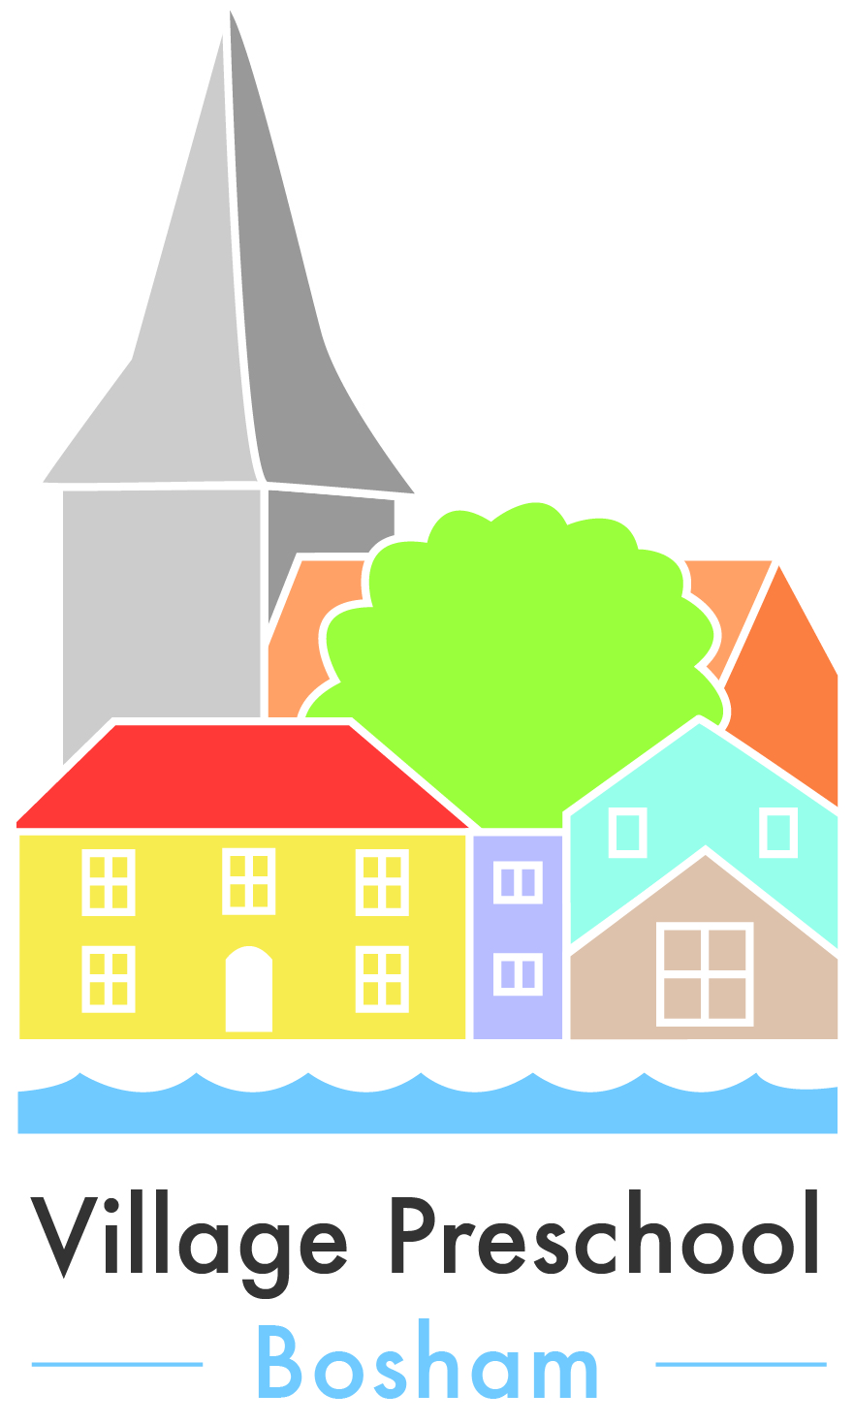

No Smoking, Drugs and Alcohol Policy

Village Preschool Bosham operates a strict no smoking policy throughout the Preschool to protect the children.

- Village Preschool Bosham does not allow smoking on the premises (including use of e-cigarettes). This includes outside spaces.

- Preschool staff are not permitted to smoke (including use of e-cigarettes) whilst in charge of children, whether inside or outside, for example Preschool outings

- Preschool staff are not permitted to smoke whilst wearing Preschool uniform.

- Parents/carers, staff, volunteers, visitors and contractors are asked not to smoke or use e-cigarettes in or around the immediate building

- Preschool staff must support this policy and ensure that it is observed at all times

Village Preschool Boshamoperates a strict no drugs or alcohol policy during usual opening hours throughout the Preschool to protect the children.

- Staff will not be permitted to work in the Preschool under the influence of drink or drugs

- Staff must notify the Manager of any medications that may affect their ability to function. A risk assessment must then be completed.

- Failure to comply with this policy by staff or volunteers may lead to disciplinary action

- Parents visiting the building during usual opening hours under the influence of drink or drugs will be instructed to leave. If it is deemed that a parent or carer is under the influence, the alternative Emergency Contact will be called to pick up the child. The Manager will be informed, the incident recorded and reference made to the safeguarding policy, with possible discussion and contact made with MASH if the Manager feels necessary action is needed to ensure the ongoing wellbeing of the child. (Please refer to our Safeguarding Policy for full details).

