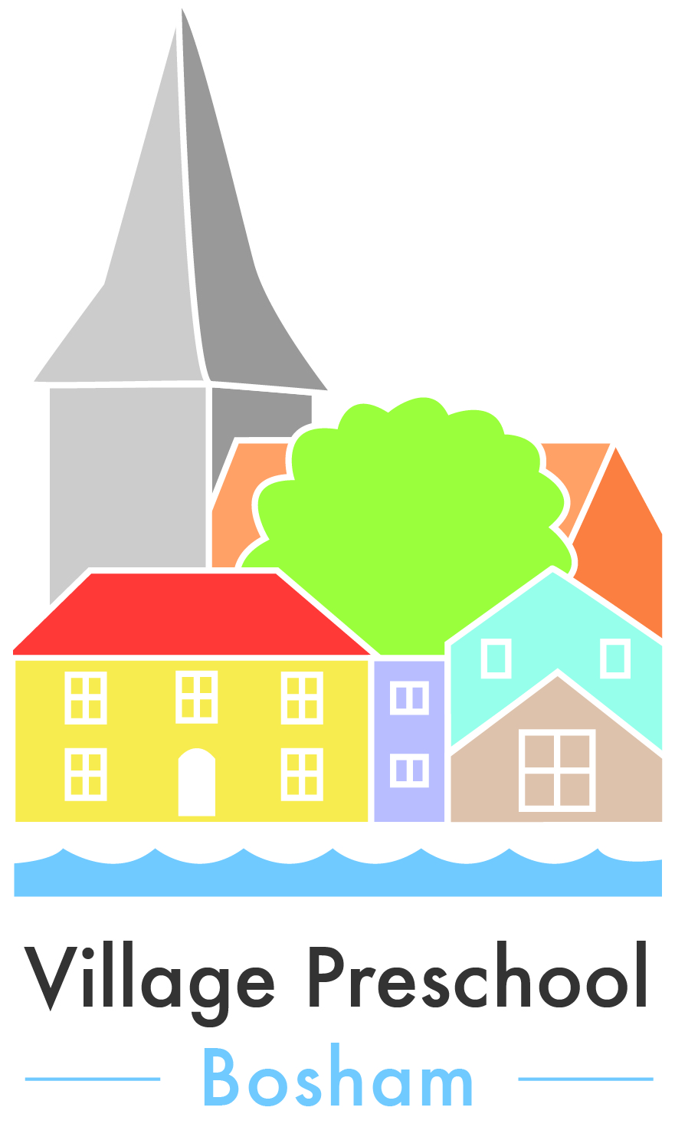

FOOD AND DRINK POLICY
This Preschool regards snack time as an important part of the setting’s session/day. Eating represents a social time for children and adults and helps children to learn about healthy eating.
At snack and meal times, we aim to promote healthy eating which meets the children’s individual dietary needs.
· Before a child starts to attend the setting, we find out from parents their children’s dietary needs and preferences, including any allergies.
· We record information about each child’s dietary needs in her/his registration form and parents sign the form to signify that it is correct.
· We regularly consult with parents to ensure that our records of their children’s dietary needs – including any allergies – are up to date
· We display current information about individual children’s dietary needs so that all staff and volunteers are fully informed about them.
· We implement systems to ensure that children receive only food and drink that is consistent with their dietary needs and preferences as well as their parents’ wishes.
· We include foods from the diet of each of the children’s cultural backgrounds, providing children with familiar foods and introducing them to new ones.
· We take care not to provide food containing nuts or nut products and are especially vigilant where we have a child who has a known allergy to nuts.
· Through discussion with parents and research reading by staff, we obtain information about the dietary rules of the religious groups to which children and their parents belong, and of vegetarians and vegans, and about food allergies. We take account of this information in the provision of food and drinks.
· We require staff to show sensitivity in providing for children’s diets and allergies. Staff do not use a child’s diet or allergy as a label for the child or make a child feel singled out because of her/his diet or allergy.

· We organise snack time so that it is a social occasion in which children and staff participate.
· We use meal and snack times to help children to develop independence through making choices, serving food and drink and feeding themselves.
· We provide children with utensils that are appropriate for their ages and stages of development and that take account of the eating practices in their cultures.
· We have fresh drinking water constantly available for the children. We inform the children about how to obtain the water and that they can ask for water at any time during the session/day.
· For children who drink milk, we participate in the ’Cool Milk’ scheme.
Celebratory Cake and Sweets in Setting
Whilst we appreciate that children and their parents like to celebrate Birthday’s and special occasions by bringing sweets and cake into setting to be shared amongst the children present.
Please DO NOT bring sweets or cake into setting that contains nuts.
Please read the dietary labels of the items you are bringing into setting carefully.
Any foods containing nuts will be returned to parents.

